

 Know Your TX – Dissecting a Transaction

**Objective/Aim:**  
 The primary objective of this lab is to dissect a blockchain transaction (TX) to understand its fundamental structure, lifecycle, and function within a decentralized network. This involves analyzing how transactions facilitate value

transfer and smart contract interactions, and identifying the cryptographic components that guarantee security, authenticity, and immutability.

**Apparatus/Software Used:**

* Laptop/PC
* A blockchain explorer (e.g., Etherscan.io)

**Theory/Concept:**

**1. What is a Blockchain Transaction?**

In the context of cryptocurrencies, a **transaction** is a cryptographically signed instruction created by a user (from an Externally Owned Account or EOA). It is the *only* way to change the state of the blockchain. Every action, from sending coins (like ETH) to another wallet, to executing a function on a complex smart contract, must be initiated through a transaction.

Once a transaction is verified by network participants (validators) and included in a block, it becomes a permanent and unalterable part of the public ledger.

#### 2. Anatomy of a Cryptocurrency Transaction

Dissecting a blockchain transaction, particularly one on an EVM-compatible chain like Ethereum, means breaking it down into its core data fields.

* **from**: The address of the sender who is initiating and signing the transaction.
* **to**: The recipient's address. This can be another user's wallet or, critically, the address of a **smart contract**.
* **value**: The amount of the native cryptocurrency (e.g., Ether) to be transferred. For smart contract interactions that don't involve sending Ether, this can be zero.



• **data**: This field is crucial for smart contracts. When the to address is a smart contract, the data payload contains the specific function the sender wants to execute, along with any necessary arguments or parameters for that function. For a simple transfer of coins, this field is usually empty.

• **gasLimit**: The maximum amount of "gas" (computational effort) the sender is willing to spend on the transaction. Every operation on the blockchain costs gas. This acts as a safety mechanism to prevent a faulty smart contract from depleting all the sender's funds.

• **gasPrice / maxFeePerGas**: The price the sender is willing to pay per unit of gas. This is the fee paid to network validators to process and include the transaction in a block. Higher gas prices incentivize validators to prioritize the transaction.

• **nonce** (Number used once): A mandatory, sequential counter for each transaction sent from a specific address. It ensures transactions are processed in the correct order and prevents "replay attacks" where a malicious actor could rebroadcast an old transaction.

#### 3. The Transaction Lifecycle: From Mempool to Finality

A transaction goes through several distinct stages before it becomes a permanent part of the blockchain:

1. **Creation & Signing:** A user's wallet assembles the transaction data (to, value, data, etc.) and uses the user's private key to generate the digital signature (v, r, s).
2. **Broadcast:** The signed transaction is broadcast to the peer-to-peer network of nodes.
3. **Mempool:** The transaction enters a "waiting area" on each node called the **mempool** (memory pool). It sits here with other pending transactions, waiting to be selected by a validator.
4. **Block Inclusion:** A validator selects transactions from the mempool (usually prioritizing those with higher gas fees) and includes them in a new block they are building.
5. **Confirmation & Finality:** The validator broadcasts the new block to the network. Other nodes verify its validity. Once the block is accepted and subsequent blocks are built on top of it, the transaction is considered confirmed and achieves **finality**, meaning it is practically irreversible. The state change (e.g., updated account balances or new data in a smart contract) is now a permanent record.

**Procedure:**

**Step 1: Locate the Transaction**

1. Navigate to a blockchain explorer like Etherscan.
2. Obtain the **Transaction Hash (Txn Hash)** of the transaction you wish to analyze. For this experiment, we will use the hash from the provided image: 0xb2a75931405a462ee99b242b642e075f922b360d640046e27142726653d47083
3. Paste this hash into the search bar of the explorer and press Enter. The transaction details page will load.

#### Step 2: Analyze the High-Level Overview

Observe the main "Transaction Action" and overview panel to understand the transaction's purpose and status.

* **Transaction Action:** Note the summary.
  + *Observation:* The action is a Transfer of 0.020033168 ETH ($73.61) to a specific Fee Recipient.
* **Status:** Check if the transaction was successful.
  + *Observation:* The status is confirmed as Success.
* **Block:** Identify the block number in which the transaction was included.
  + *Observation:* The transaction is in block 22974060.
* **Timestamp:** Record the time of confirmation.
  + 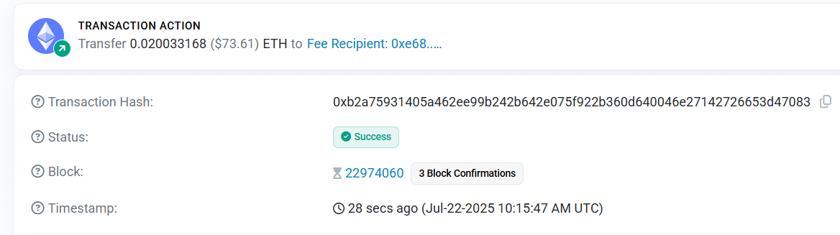*Observation:* The timestamp is Jul-22-2025 10:15:47 AM UTC.

#### Step 3: Dissect the Core Components (The "Who" and "What")

Examine the primary fields that define the transaction's core purpose.

* **From:** Identify the sender's address.
  + *Observation:* The sender is quasarbuilder.eth.
* **To:** Identify the recipient's address.
  + *Observation:* The recipient is the address 0xe688b84b23f322a994A53dbF8E15FA82CDB71127.
* **Value:** Note the exact amount of cryptocurrency transferred.
  + *Observation:* The value transferred is 0.020033167782832038 ETH.

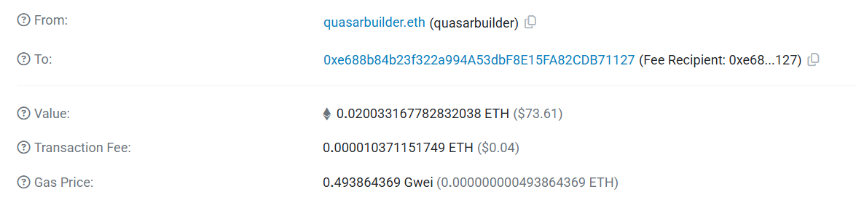

#### Step 4: Examine the Transaction Cost (The "How Much")

Analyze the fees associated with getting the transaction processed by the network.

* **Transaction Fee:** Find the total cost paid to the validator.
  + *Observation:* The fee was 0.000010371151749 ETH ($0.04).
* **Gas Limit & Usage:** Note the maximum gas allocated and how much was actually used.
  + *Observation:* The Gas Limit was 21,000 and the transaction used all 21,000 units (100%). This is standard for a simple ETH transfer.
* **Gas Price:** Observe the price paid per unit of gas. This is calculated from the Base Fee and Priority Fee (tip).
  + *Observation:* The effective Gas Price was 0.493864369 Gwei. The Base fee was fully paid, and the Max Priority fee (tip to the validator) was 0 ETH.
* **Burnt Fees:** Note the portion of the fee that was burned by the network protocol (as per EIP-1559).
  + 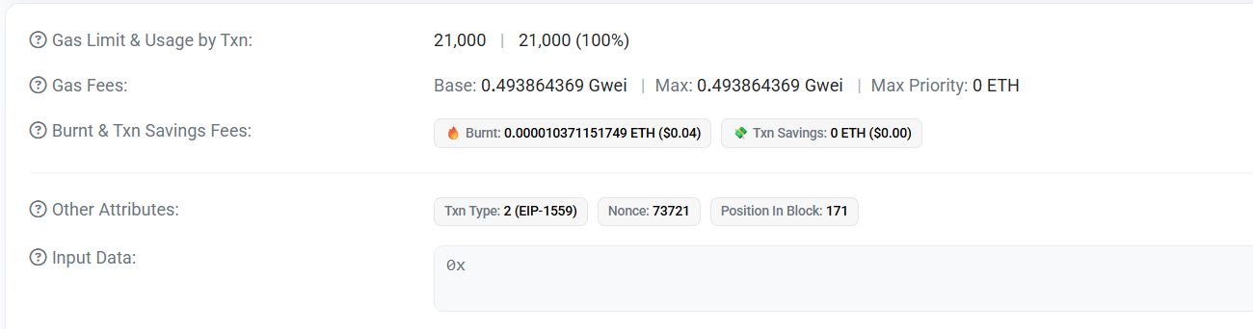*Observation:* 0.000010371151749 ETH was burnt

#### Step 5: Investigate Other Attributes and Data

Look at the remaining metadata that provides deeper context about the transaction's place in the blockchain.

* **Txn Type:** Identify the transaction standard used.
  + *Observation:* It is a Type 2 (EIP-1559) transaction, which is the modern standard for Ethereum fees.
* **Nonce:** Record the transaction's nonce. This is the transaction count from the sender's address.
  + *Observation:* The nonce is 73721.
* **Position in Block:** Find where the transaction was placed within its block.
  + *Observation:* It was the 171st transaction in the block.
* **Input Data:** Examine the data field. This is critical for determining if it was a simple transfer or a smart contract interaction.
  + *Observation:* The Input Data is 0x, indicating it is empty. This confirms the transaction was a simple value transfer and did not call any smart contract functions.

**Observation Table:**

Upon analyzing the transaction with the hash 0xb2a7593...d47083, the following observations were made:

1. **Nature of the Transaction:** The transaction was a simple peer-to-peer value transfer. The **Input Data** field was empty (0x), which confirms that no smart contract function was called. This was a standard transfer of cryptocurrency from one wallet to another.
2. **Parties and Value:** The sender, identified by the ENS name quasarbuilder.eth, successfully transferred **0.020033167782832038 ETH** (valued at $73.61 at the time) to the recipient address 0xe688b...71127.
3. **Transaction Costs and Efficiency:**
   * The total **Transaction Fee** was a nominal **0.000010371151749 ETH** ($0.04).
   * The transaction utilized the entire **Gas Limit** of **21,000 units**, which is the standard gas amount for a basic ETH transfer.
   * The transaction was processed as a **Type 2 (EIP-1559)** transaction. The fee structure consisted of a **Base Fee** of 0.493864369 Gwei and a **Max Priority Fee** (tip) of 0 ETH. This indicates that the sender did not add an extra tip to incentivize the validator, relying on the base network fee for inclusion.
   * The entirety of the base fee (0.000010371151749 ETH) was **burnt**, as per the EIP-1559 protocol.
4. **Confirmation and Finality:**
   * The transaction status was confirmed as **Success**.
   * It was included in **Block 22974060** and was the **171st** transaction within that block.
   * At the time of observation, it had received **3 Block Confirmations**, indicating it is securely recorded and has achieved finality on the blockchain.
5. **Sender-Specific Data:** The transaction had a **Nonce** of **73721**. This signifies that this was the 73,721st transaction initiated from the quasarbuilder.eth account, ensuring the correct chronological processing of their transactions.